

PRESS RELEASE Prague, 27th June 2016

Olympic performs in BB Centrum

Baarův Park, which is part of the multifunctional BB Centrum complex in Prague 4, resonated once again with the sounds of music in June. For the third time PASSERINVEST GROUP prepared an afternoon and evening full of quality music and good times. Visitors to Baarův Park had the opportunity to listen to the greatest hits of Olympic as well as the world-renowned songs of the Beatles as performed by Brouci Band - The Beatles Revival. There was also an entertaining accompanying programme and stands with refreshments from local restaurants.

An accompanying programme was prepared for visitors in addition to the musical performances by the aforementioned bands. Right in Baarův Park they could play Pétangue, get a photograph as a rock star in the photo corner for a souvenir or try their skill at the Balance Club Brumlovka stand. There was a booth with face painting and crafts for the smallest visitors. A photographic contest on the theme “Enjoying today’s concert in Baarův Park” took place on the BB Centrum Facebook page throughout the entire event. The winner of this contest received a gift basket valued at 2000 crowns from PASSERINVEST GROUP.

BB Centrum is one of the largest and most successful development projects in the Czech Republic. But it is not just an office centre – BB Centrum comprises a multifunctional complex with all the civic amenities, offering job and living opportunities, leisure activities, education and also cultural events. This year BB Centrum has already seen a children’s day, the second BookBooth was opened and at the end of August there will be CinemaBus stop here for a number of days.

You can find news and current information on the events in BB Centrum at http://www.facebook.com/BBCentrum.

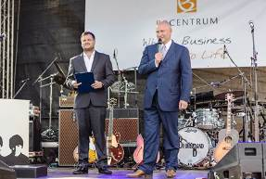

Radim Passer, Chairman of the Board of Directors of PASSERINVEST GROUP, welcome speech at the concert of Olympic and Brouci Band - The Beatles Revival in Baaruv park in BB Centrum

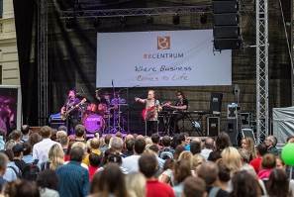

Concert of Olympic in Baaruv park in BB Centrum

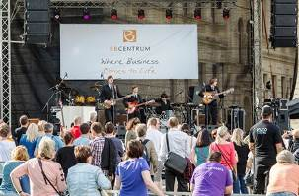

Concert of Brouci Band - The Beatles Revival in Baaruv park in BB Centrum

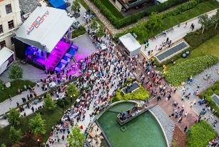

Concert of Olympic and Brouci Band - The Beatles Revival in Baaruv park in BB Centrum

For more information and photographs in print quality please contact:

Kristýna Samková, Head of Marketing and PR
PASSERINVEST GROUP, a.s.
Tel.: (+420) 221 582 111, fax: (+420) 222 515 521
Mobil: (+420) 602 186 708
E-mail: Kristyna.Samkova@Passerinvest.cz
www.passerinvest.cz, www.bbcentrum.cz

Marcela Štefcová
Crest Communications a.s.
Tel.: (+420) 222 927 125
Mobile: (+420) 731 613 669
E-mail: marcela.stefcova@crestcom.cz
www.crestcom.cz

ABOUT THE DEVELOPER

PASSERINVEST GROUP, a. s., is a purely Czech development company, whose name is primarily connected with the construction of the multifunctional BB Centrum complex in Prague 4 – Michle. The company, founded in 1991 by Radim Passer, built a very good name on both a domestic and international level with this, the most successful and extensive Czech project of its kind. This is not only due to the quality of the implemented projects and the high level of provided services, but also to a sense of fair play, an accommodating relationship with the tenants/users of the buildings and the responsibility towards society and the environment. PASSERINVEST GROUP also has other interesting development projects in its portfolio.

